Provash Budden
Deputy Senior Vice President of Emergency Programs

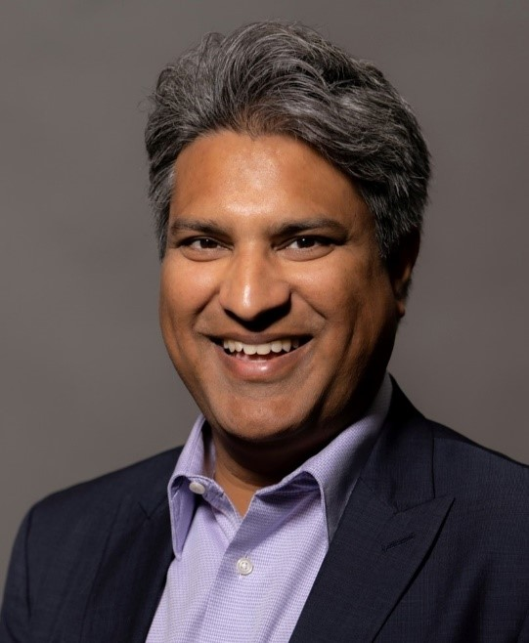

Americares Deputy Senior Vice President of Emergency Programs Provash Budden oversees Americares readiness, response and recovery programs in the U.S. and around the world. He is tasked with deploying emergency response teams, including medical teams, coordinating large-scale deliveries of medicines and relief supplies and overseeing recovery programs that restore health services for disaster survivors.

Americares responds to more than 30 natural disasters and humanitarian crises worldwide each year, establishes long-term recovery projects and brings preparedness programs to communities vulnerable to disasters. In addition to responding to hurricanes, wildfires, earthquakes and disease outbreaks, Budden’s team also responds to humanitarian emergencies cause by conflict in Ukraine, Syria, Yemen, Israel and Gaza.

He joined Americares in 2023 with more than two decades of experience in design, implementation and management of sustainable development programs, including programming for survivors of natural disasters and complex humanitarian crises.

He previously worked as a consultant on projects assisting earthquake survivors in Türkiye and Syria and the humanitarian crisis caused by the war in Ukraine. Prior to that he spent nearly 14 years with Mercy Corps where he led emergency response teams, served as country director in both Sudan and Colombia and as regional director for the Americas based in Bogotá. He also spent 10 years with Catholic Relief Services working in the Dominican Republic, Egypt, India, Indonesia, Iraq and Sri Lanka.

Over the years, Budden has been on the frontlines of dozens of emergencies, including the Haiti earthquake in 2021, Hurricanes Eta and Iota in Central America in 2020, Hurricane Dorian in the Bahamas in 2019, Hurricane Maria in Puerto Rico in 2017 and the continued humanitarian crises for Venezuelans and Central American migrants.

He earned a bachelor's degree in international affairs and Spanish from Whittier College in California and a master’s degree in international affairs from Columbia University in New York. He is fluent in English and Spanish.

