Eric Jovan Pérez-López
Puerto Rico Country Director

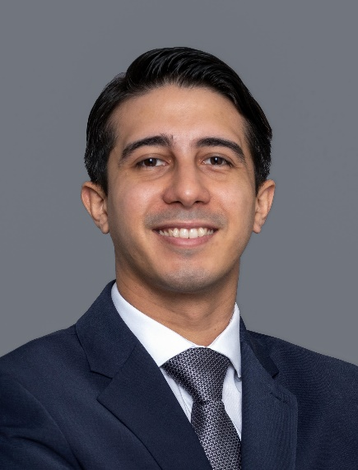
Americares Puerto Rico Country Director Eric Jovan Pérez-López, MPH, oversees all aspects of the organization’s health programming in Puerto Rico. He is responsible for managing Americares ongoing disaster recovery operations, implementing programs that meet survivors’ long-term health needs and directing initiatives that strengthen health systems in vulnerable communities.

Pérez-López also serves as a member of Americares senior Leadership Team, supporting the CEO in implementing the strategy and achieving the mission of the health-focused relief and development organization.

Pérez-López, who is based in San Juan, brings to Americares nearly a decade of experience in public health. He joined the organization as an emergency response area coordinator for the devastating 2017 hurricanes and has since held a number of leadership roles, including deputy Puerto Rico recovery director, deputy Puerto Rico country director and regional response hub operations lead. He has also been on the frontlines of many of Americares emergency responses, including Hurricanes Irma, Maria, Dorian and Fiona, the 2020 Puerto Rico earthquakes and the COVID-19 pandemic.

In 2021, Pérez-López played a key role in Americares response to the COVID-19 pandemic in Puerto Rico and the U.S. Virgin Islands, leading a successful U.S. Centers for Disease Control and Prevention-funded project to reinforce COVID-19 vaccine confidence among health care personnel in federally qualified health centers and professional health care associations.

Prior to joining Americares, Pérez-López worked as a contractor for the U.S. Centers for Disease Control and Prevention in San Juan, where he served as a public health advisor and as the deputy lead of partnerships in Puerto Rico during the CDC’s Zika response. During that time, he also served as secretary for the Puerto Rico Public Health Association.

Pérez-López earned a Master of Public Health degree from the Ponce School of Medicine and Health Sciences in Ponce, Puerto Rico, and a bachelor’s degree in general science from Pontificia Universidad Católica de Puerto Rico. He is currently pursuing an MBA at the University of Puerto Rico’s Rio Piedras Graduate School of Business Administration. He is fluent in English and Spanish.

