Elena Ateva
Director of Climate and Disaster Resilience
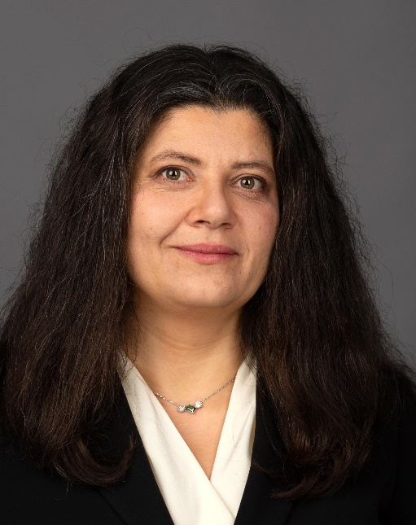
Americares Director of Climate and Disaster Resilience Elena Ateva oversees a team that develops innovative global programming that prevents or addresses the health impacts of climate change.

She works closely with health providers and clinic staff serving low-income and uninsured patients, ensuring they have the resources to protect the most vulnerable patients from hurricanes, wildfires, flooding, extreme heat and other weather events intensified by climate change. Americares supports over 4,000 health centers worldwide with transformative health projects, medicine, and medical supplies, improving the health of millions of people affected by poverty or disaster every year.
Ateva leads Americares growing portfolio of climate resilience and preparedness programs, including the Climate Resilience for Frontline Clinics Toolkit and the Climate Health Equity for Community Clinics Program—both collaborations with the Center for Climate, Health, and the Global Environment at Harvard T.H. Chan School of Public Health (Harvard Chan C-CHANGE).
Prior to joining Americares, Ateva served as deputy director of heat, health and gender at the Atlantic Council’s Adrienne Arsht-Rockefeller Foundation Resilience Center, which focuses on individual and community climate resilience. During her tenure, she successfully developed an organization-wide strategy integrating gender and health into the center’s climate adaptation work and oversaw its implementation globally.
Ateva also previously worked for the White Ribbon Alliance for seven years, where she held a number of leadership roles including senior advocacy and communications manager, and maternal health advisor for the USAID Health Policy Plus project, among others. During this time, Ateva developed a new portfolio for the organization focused on the impact of climate change on reproductive, maternal, newborn and child health. She also worked to position the impact of climate change on women’s health in influential global forums and fostered collaborative partnerships with diverse stakeholders in the nonprofit and humanitarian aid sector. Ateva also worked as an advocate for respectful maternity care and researched gender-based violence as a consultant for the American Refugee Committee.
Ateva earned her bachelor’s degree in political science and German from Luther College in Iowa and her juris doctor degree from Hamline University’s School of Law. She speaks English, German, Russian and French, in addition to her native Bulgarian.

